Poisson si gauss

- Realizarea experimentala a unei analize statistice;

- Marimi caracteristice unei distributii statistice: valoare medie, dispersie, abatere standard, etc.

 | Val. medie | dispersie | Std(abatere standard) | skew | Kurtosis | ranage
Gauss | 13.84 | 14.00 | 3.74 | 0.29 | -0.02 | 4-28
poisson | 3.41 | 3.44 | 1.85 | 0.54 | 0.34 | 0-11

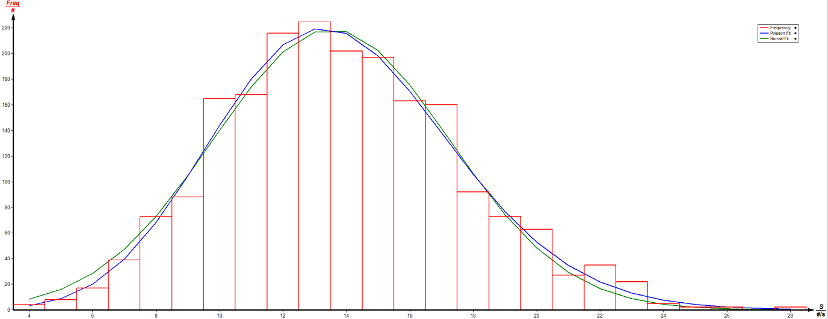
Fig 1 Gauss

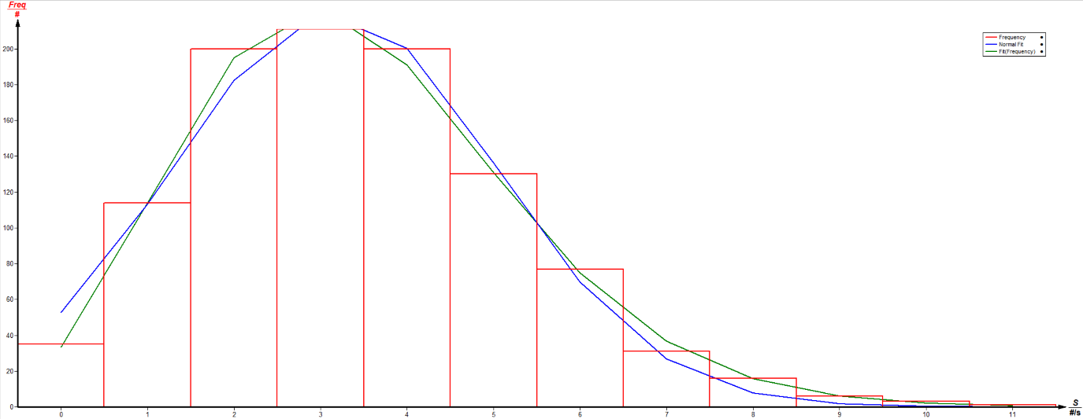
Fig2 Poisson

- Asemanari si deosebiri intre distributiile Poisson si Gauss;

